You are cordially invited to attend

**Wednesday, March 28, 2018**

**12:00 pm - 1:00 pm**

252 Erickson Hall

Michigan State University

Light refreshments provided

Kristen St. John

Professor of Geology, James Madison University

**Building a stronger DBER community:**

**disciplinary and cross-disciplinary examples**

**Abstract:**

An effective DBER community of practice is one that builds competency and capacity in DBER and generates results that can advance disciplinary teaching and learning. This presentation will draw on disciplinary and cross-disciplinary examples of recent efforts to strengthen the DBER community of practice. These include the introduction of a Strength of Evidence model, an online Toolbox for early career geoscience education researchers, efforts to identify and strategize around DBER Grand Challenges, and the initial steps taken in forming a cross-DBER-Alliance.

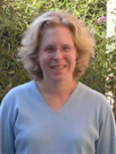**Kristen St. John** is a Professor of Geology at James Madison University. She earned her B.S. in Geology at Furman University (1992), and her M.S. (1995) and a Ph.D. (1998) in Geoscience from The Ohio State University. Her research focuses on geoscience education and the marine sediment record of past climate conditions. She was the Editor-in-Chief (2012-2017) of the Journal of Geoscience Education. She is PI on community building projects in geoscience education research (GER) including the GER Community Synthesis and Planning Project and the Framework for Transformative Geoscience Education Research project. An active researcher in the International Ocean Discovery Program (IODP), she has sailed as a marine sedimentologist on several ocean expeditions. Her teaching responsibilities include a large general education course on Earth systems and climate change, Earth science for pre-service teachers, and courses for majors on geowriting and communication, and on paleoclimatology/paleoceanography. She received the JMU General Education Distinguished Teacher Award in 2013 and the JMU College of Science and Math Outstanding Teaching Award in 2014. She was recognized as Geological Society of America (GSA) Fellow in 2016.

../../../private/var/folders/gk/qj1hgs9s3m1180sybw1w7ry80000gr/T/com.apple.Preview/PreviewTemp-dexzas/MSU-Wordmark-Green-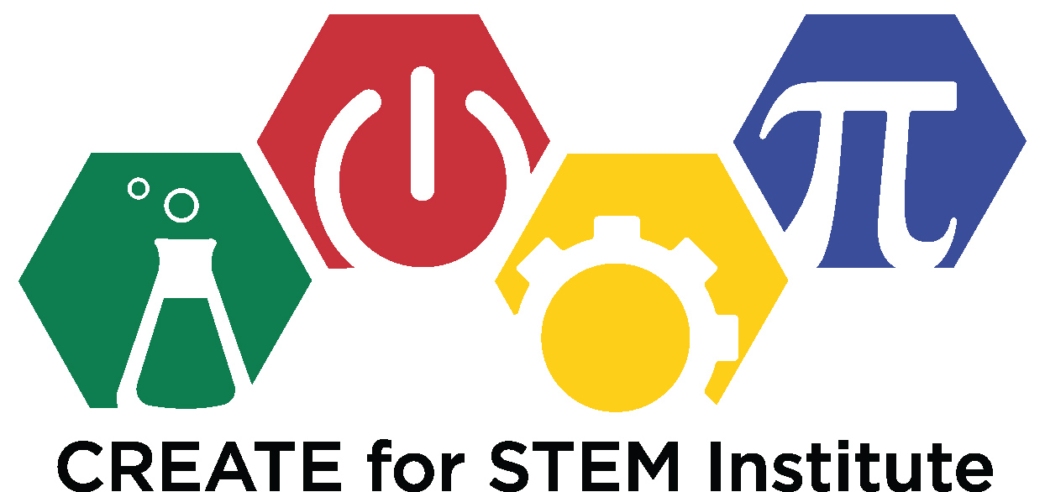

This speaker is part of the **CREATE Seminar Series**.

For more information, please visit

http://create4stem.msu.edu/seminar-series