You are cordially invited to attend:

Wednesday, January 25, 2017

12:00 p.m. - 1:00 p.m.

252 Erickson Hall

Michigan State University

Light refreshments provided

John Krupczak

Professor of Engineering, Hope College

Progress in the Development of an

Engineering Reasoning Assessment for General Education

**Abstract:**

Despite the extent to which technology and the products of engineering enable the activities of daily life for most Americans, limited work has been done measuring the degree to which undergraduate students possess a broad understanding of the principles, products, and processes of engineering.  Improvements in the measurement of learning gains of engineering majors are being made thanks in part to engineering accreditation criteria advanced under ABET EC 2000. However, methods of determining the degree of technological understanding by the majority of undergraduates who are not engineering students remain underdeveloped.   Work will be described concerning an effort to develop an engineering literacy assessment suitable for use with students outside of the STEM disciplines.  Initial activity focuses on abilities related to the identification and characterization of systems along with the ability to synthesize systems to achieve a particular function in a given technological domain.  Preliminary data from undergraduate non-STEM majors in different institutions will be described.

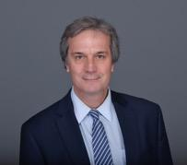

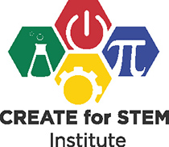**John Krupczak** is a professor of engineering at Hope College in Holland, Michigan. He has been a Senior Fellow of the Center for the Advancement of the Scholarship of Engineering Education (CASEE) of the National Academy of Engineering. Krupczak was founding chair of the Technological and Engineering Literacy Division of the American Society for Engineering Education (ASEE).  From 2013-2016, he served as a Program Director in the Division of Undergraduate Education at the National Science Foundation (NSF).  At NSF, Krupczak’s program activities included: Improving Undergraduate STEM Education (IUSE); Advanced Technological Education (ATE); Scholarships in Science, Engineering, and Technology (S-STEM); and the NSF Innovation Corps for Learning (I-Corps L).  His interests include engineering and STEM literacy for non-engineers, improvement of introductory engineering courses, and functional reasoning in the context of engineering analysis and design.  He received a Ph.D. in Mechanical Engineering from the University of Massachusetts and a B.A. in Physics from Williams College.

../../../private/var/folders/gk/qj1hgs9s3m1180sybw1w7ry80000gr/T/com.apple.Preview/PreviewTemp-dexzas/MSU-Wordmark-Green-

This speaker is part of the CREATE Seminar Series. For more information, please visit

http://create4stem.msu.edu/seminar-series